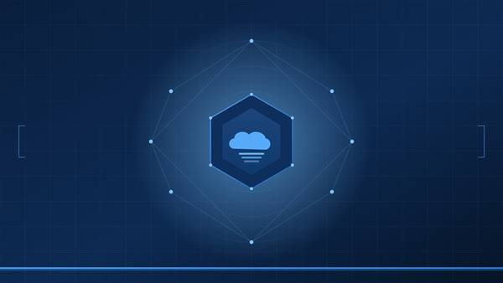
TECHNICAL ADVISORY · PRIVATE CLOUD OPERATIONS
<Project Name>
<VCF Version> / <VCF Automation Version>

Executive Summary
PREPARED: <Month Year> · AUDIENCE: <customer>, <groups>

1. Overview
<2–3 paragraphs: What is this solution? What persistent problems does it solve? Why was it built? Write for a non-technical audience.>

2. Business Value
<Table mapping outcomes to practical business impact. Use the format below.>
Outcome | What it means in practice
<Outcome 1, e.g. Reclaimed storage capacity> | <Plain-language explanation of how this benefits operations, budget, or risk.>
<Outcome 2> | <Explanation>
<Outcome 3> | <Explanation>
<Outcome 4> | <Explanation>
<Outcome 5> | <Explanation>
<Outcome 6> | <Explanation>

3. How It Works (At a Glance)
<1 paragraph introducing the pipeline concept, then a stage-by-stage table. Keep each stage description to one sentence.>
Stage | What happens
<Stage 1> | <One-sentence description>
<Stage 2> | <One-sentence description>
<Stage 3> | <One-sentence description>
<Stage 4> | <One-sentence description>
<Stage 5> | <One-sentence description>
<Stage 6> | <One-sentence description>

<Callout title, e.g. Default Mode is Dry Run>
<Callout body — a single important safety or operational note the reader must know.>

4. Operating Model
<1 paragraph describing who owns the workflow and where it runs, then a roles table.>
Role | Responsibility
<Role 1, e.g. Workflow Owner> | <Description of responsibilities>
<Role 2, e.g. Operator> | <Description>
<Role 3, e.g. Service Owner> | <Description>

5. Risk Position
Risk | How the design mitigates it | Residual
<Risk 1> | <Mitigation description> | <Low/Medium/High>
<Risk 2> | <Mitigation> | <Level>
<Risk 3> | <Mitigation> | <Level>
<Risk 4> | <Mitigation> | <Level>
<Risk 5> | <Mitigation> | <Level>

6. Reporting
<Describe what each run produces in terms of log output and how it can be queried. Bullet the key data points included in the summary.>

7. Recommended Next Steps
# | Action | Owner
1 | <First action, e.g. Approve deployment to non-production> | <Owner>
2 | <Second action> | <Owner>
3 | <Third action> | <Owner>
4 | <Fourth action> | <Owner>
5 | <Fifth action> | <Owner>

8. Glossary
<Define every term a non-technical reader might not know. Use the table format below.>
Term | Plain-language meaning
<Term 1> | <Definition>
<Term 2> | <Definition>
<Term 3> | <Definition>
<Term 4> | <Definition>
<Term 5> | <Definition>

